N8N AUTOMATION REPORT
Outlook Vacancy
Email Tracker
━━━━━━━━━━━━━━━━━━━━━━
Microsoft Outlook • OpenAI GPT • Microsoft Excel

Version 1.0 | 2025

📋 | Project Snapshot

Trigger | Microsoft Outlook — New Email Received
Platform | N8N
Integrations | Microsoft Outlook, OpenAI GPT, Microsoft Excel
AI Model | OpenAI GPT (multiple instances)
Output | Structured vacancy data appended to MS Excel worksheet

⚙ | Workflow Diagram

The n8n workflow diagram below shows the full pipeline — from the Microsoft Outlook trigger through AI classification, vacancy extraction, and final output to Microsoft Excel.
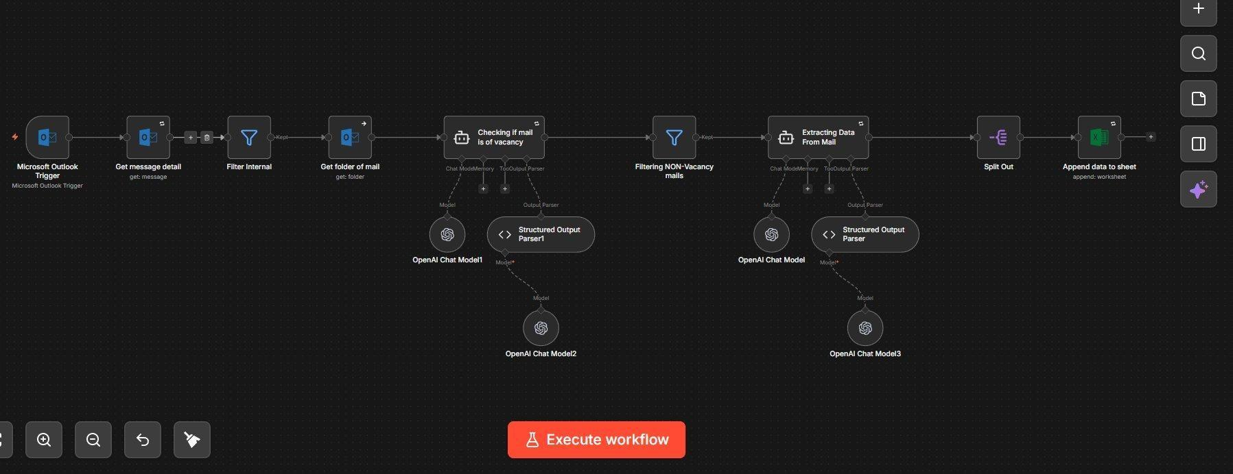
Figure 1: Complete n8n Workflow — Outlook Vacancy Email Tracker
🔍 | Overview

This workflow monitors a Microsoft Outlook inbox in real time and automatically identifies job vacancy emails from the incoming mail stream. Each email is first checked for internal origin and folder context, then an AI agent determines whether the email pertains to a job vacancy.
Emails that pass this classification are passed to a second AI agent that extracts structured vacancy details — such as job title, company, location, and requirements — and appends them as a new row in a Microsoft Excel spreadsheet, creating a continuously updated, searchable vacancy tracker without any manual effort.

▶ | How It Works — Step by Step

1 | Microsoft Outlook Trigger
 | The workflow fires automatically whenever a new email arrives in the monitored inbox.

2 | Retrieve Full Message Details
 | Full message details are retrieved from Outlook to access the subject, body, sender, and all associated metadata.

3 | Filter Internal / System Emails
 | A filter node removes internal and system-generated emails that should not enter the processing pipeline, reducing noise before any AI processing occurs.

4 | Get Folder of Mail
 | The folder of the email is retrieved to provide additional context that assists the AI classification step in making an accurate determination.

5 | AI Classification — Is It a Vacancy?
 | An AI Agent (with two OpenAI model instances and a Structured Output Parser) reads the email content and context and classifies whether the email is vacancy-related. Only emails that pass are allowed through.

6 | Filter Non-Vacancy Emails
 | A second filter node discards all emails that were not classified as vacancy emails by the AI agent, ensuring only relevant messages proceed to extraction.

7 | AI Extraction — Structured Vacancy Data
 | A second AI Agent uses another OpenAI model and Structured Output Parser to extract structured vacancy data from the email body — including job title, company, location, salary, and requirements — and returns valid JSON.

8 | Split Out
 | The Split Out node separates multiple data items if the extraction yields more than one vacancy from a single email, ensuring each vacancy becomes its own discrete record.

9 | Append to Microsoft Excel
 | Structured vacancy data is appended as a new row to a Microsoft Excel worksheet, building a continuously updated, searchable vacancy tracker automatically.

⚡ | Challenges & How the Workflow Addresses Them

⚡ Inbox noise — not all emails are vacancy-related
→ A dedicated AI classification step (Step 5) acts as an intelligent gate, reading email content and context before anything is extracted, ensuring only true vacancy emails proceed.

⚡ Internal / system emails polluting the pipeline
→ A rule-based filter (Step 3) removes internal emails early in the flow before any AI processing occurs, reducing cost and avoiding irrelevant classifications.

⚡ Unstructured email body — vacancies have no fixed format
→ The extraction AI Agent uses a Structured Output Parser with a defined JSON schema, forcing the model to return consistently structured fields regardless of how the original email was written.

⚡ Two AI tasks risk interference if combined into one
→ Classification and extraction are intentionally split into two separate AI Agent nodes with distinct prompts and models, keeping each task focused and reducing hallucination risk.

⚡ Single email may contain multiple vacancy listings
→ The Split Out node ensures each individual vacancy becomes its own data item before being written to Excel, preventing multiple vacancies from being collapsed into a single row.

🔧 | Tools & Integrations

Tool / Service | Role in Workflow
Microsoft Outlook Trigger | Monitors inbox and fires on every new email
Outlook Node (get: message) | Fetches full message content and metadata
Outlook Node (get: folder) | Retrieves folder context for classification
Filter Node (×2) | Removes internal emails and non-vacancy emails
OpenAI GPT (Classification) | Determines if email is vacancy-related
OpenAI GPT (Extraction) | Pulls structured vacancy data from email body
Structured Output Parser (×2) | Enforces JSON schema on both AI outputs
Split Out Node | Splits multiple vacancies into individual items
Microsoft Excel | Stores all extracted vacancy records as rows

End of Document

